**IST370 Lab 8 (50 points)**

**Special Join Types: Outer Joins**

* Do it on your own.
* Collaborate with ____________

1. Display a list of all customers in the CUSTOMERS table and corresponding order number. You should include those who have made at least one order as well as those who did not place any order in the past.

SELECT  c.firstname|| ‘ ‘ ||c.lastname “Customers”, o.order#

FROM customers c, orders o

WHERE c.customer#= o.customer#(+);

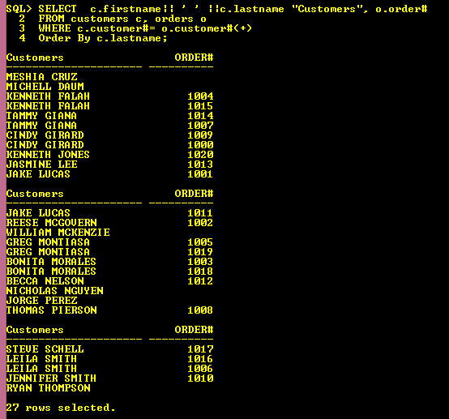

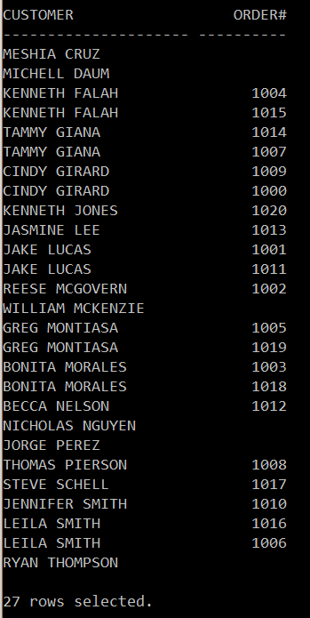

2. Identify ONLY those customers who DID NOT make any order in the past. Modify the SQL statement in Question 1 to address the request.

SELECT c.firstname|| ' ' ||c.lastname "Customers", o.order#

FROM customers c, orders o

WHERE c.customer#= o.customer#(+)

AND o.order# IS NULL;

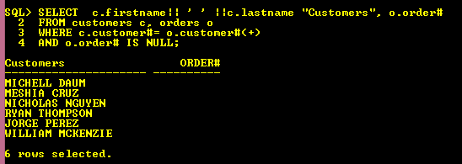

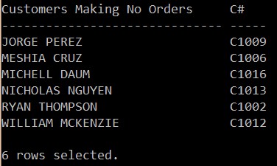

3. Display a list of all books in the COMPUTER BOOKS table (including those books that were ordered PLUS those have never been ordered).

**🡪 MANDATORY: You should use the implicit method with the outer join operator (+) to address this request.**

SELECT title, o.order#, state, c.lastname "Customers"

FROM books b, orders o, orderitems oi, customers c

WHERE c.customer#(+)= o.customer#

AND o.order# (+) = oi.order#

AND oi.ISBN (+) = b.ISBN

AND b.category = 'COMPUTER'

Order By title;

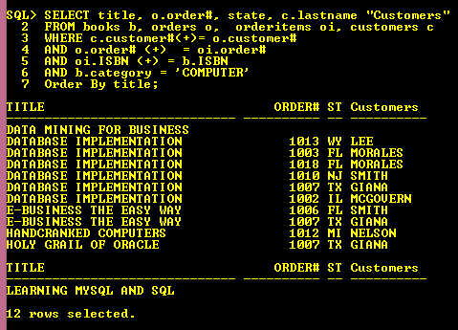

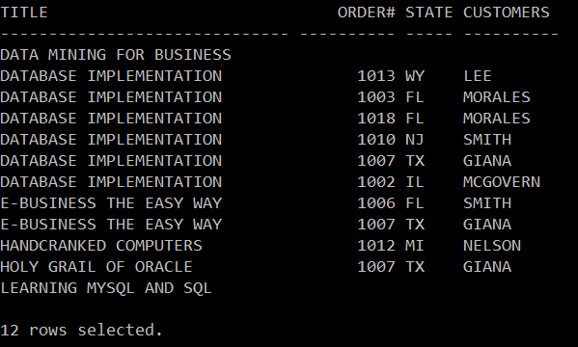

4. Addressing the same question (as in Question 3), use the explicit method to address this request (e.g., LEFT OUTER JOIN or RIGHT OUTER JOIN).

5. Find out the **computer books** that were NEVER ordered in the past. You can use either the implicit or explicit method to address this request.

SELECT title, o.order#, state, c.lastname "Customers"

FROM books b, orders o, orderitems oi, customers c

WHERE c.customer# (+) = o.customer#

AND o.order# (+) = oi.order#

AND oi.ISBN (+)= b.ISBN

AND b.category = 'COMPUTER'

AND o.order# IS NULL

AND state IS NULL

AND c.customer# IS NULL

Order By title;

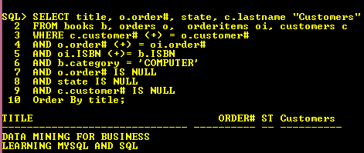

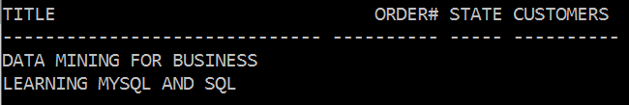

6. Display a list of all customers who live in these three states in the East Coast: FL, NY, and MA. You should include those who have ordered at least one order PLUS those never ordered any book in the past. You can use either the implicit or explicit method to address this request.

SELECT c.firstname|| ' ' ||c.lastname "Customers", state, o.order#, title

FROM orders o, orderitems oi, customers c, books b

WHERE c.customer# = o.customer#(+)

AND o.order# = oi.order# (+)

AND b.ISBN (+) = oi.ISBN

AND state IN('FL', 'MA','NY')

Order By state;

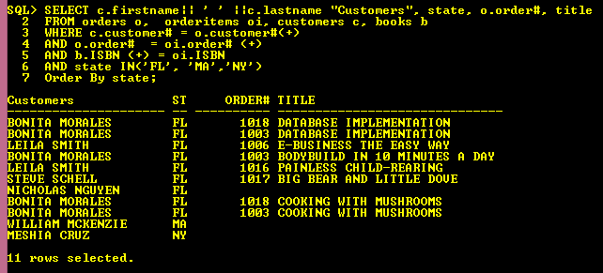

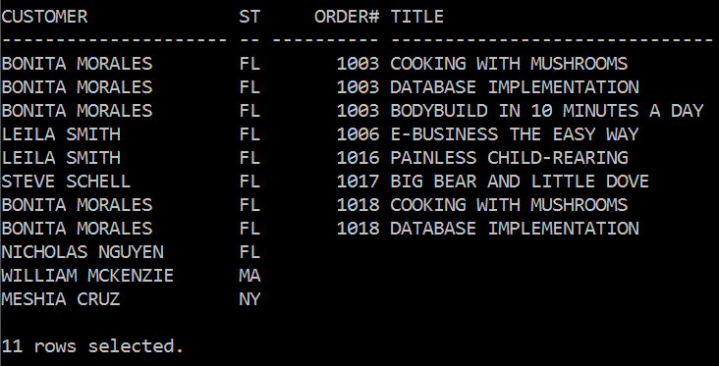

7. Display a list including all employees, along with his/her manager. You should also include the employee (i.e., Larry King) who does not have a manager.

Run the following code prior to your SELECT statement:

COLUMN "EMPLOYEE" FORMAT A15

COLUMN "MANAGER" FORMAT A15

SELECT e.firstname|| ' ' ||e.lastname "Employee",m.firstname|| ' ' || m.lastname "Manager"

FROM emp e, emp m

WHERE m.empno(+) = e.MGR_ID

Order By “Manager”;

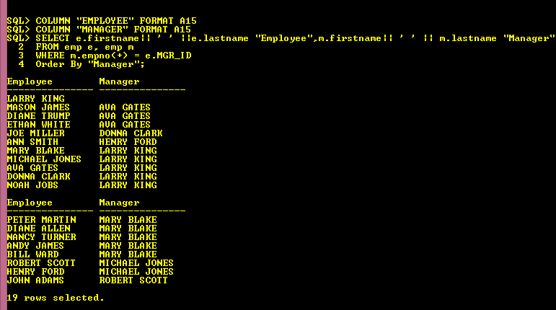

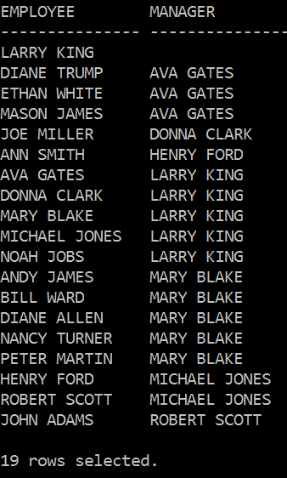

8. Identify only the employee who has no manger.

SELECT e.firstname|| ' ' ||e.lastname "Employee",m.firstname|| ' ' ||m.lastname "Manager"

FROM emp e, emp m

WHERE m.empno(+)= e.MGR_ID

AND e.MGR_ID IS NULL;

